Covid-19 Vaccines Analysis – Guidelines

Analyzing COVID-19 vaccine data is essential for understanding the effectiveness, distribution, and impact of vaccination efforts. Here's a guideline on how to approach COVID-19 vaccine data analysis:

1. DEFINE YOUR OBJECTIVES:

Determine the specific aspects of COVID-19 vaccine data you want to analyze. This could include vaccine effectiveness, distribution patterns, demographics, adverse reactions, or any other relevant factors.

1. DATA COLLECTION:

* Gather reliable and updated data from reputable sources such as government health agencies, WHO, CDC, or research institutions.
* Ensure the data includes information on vaccine types, administration dates, demographics, and any other relevant variables.

1. DATA PREPROCESSING:

* Clean the data by handling missing values, outliers, and inconsistencies.
* Format the data for analysis, ensuring it's in a structured format such as CSV or Excel.
* Normalize or standardize numerical variables if necessary.

1. EXPLORATORY DATA ANALYSIS:

* Conduct exploratory data analysis to understand the basic statistics and visualizations of the data.
* Use statistical measures and visualizations (histograms, box plots, heat maps) to identify patterns and trends in the data.

1. VACCINE EFFECTIVENESS ANALYSIS:

* Compare infection rates, hospitalization rates, and mortality rates between vaccinated and unvaccinated populations.
* Calculate vaccine effectiveness using appropriate metrics and statistical tests.

1. DEMOGRAPHIC ANALYSIS:

* Analyze vaccination rates and effectiveness across different demographics (age, gender).
* Identify any disparities in vaccine distribution and effectiveness among various demographic groups.

1. GIOSPATIAL ANALYSIS:

* Utilize geospatial data to visualize the distribution of vaccines across regions.
* Analyze vaccination rates and their correlation with infection rates in different geographic areas.

1. TIME SERIES ANALYSIS:

* Perform time-series analysis to observe the trend of vaccinations over time.
* Identify the impact of vaccination campaigns on infection rates and other relevant metrics.

1. ADVERSE REACTION ANALYSIS:

* Analyze reported adverse reactions to vaccines.
* Identify common side effects and their prevalence among different demographic groups.

1. PERDICTIVE MODELING:

* Build predictive models to forecast vaccination rates or predict future COVID-19 cases based on vaccination data.
* Use machine learning algorithms such as regression or time-series forecasting methods.

1. VISUALIZATION AND REPORTING:

* Create compelling visualizations (charts, graphs, maps) to present your findings effectively.
* Prepare a comprehensive report summarizing your analysis, methodologies, and conclusions.

1. STAY ETHICAL AND RESPONSIBLE:

* Ensure that your analysis is conducted ethically, respecting privacy and confidentiality of individuals in the data.
* Clearly state any limitations of your analysis and be cautious not to draw misleading conclusions.

TOOLS AND TECHNOLOGIES

* Use programming languages like Python or R for data analysis and visualization.
* Leverage libraries like PANDAS, MATPLOTLIB, SEABORN, PLOTLY, and GEOPANDAS for data manipulation and visualization.
* Consider using GIS (Geographical Information Systems) tools for geospatial analysis.

Describe the dataset used, data preprocessing steps, and analysis techniques applied.

### 1. ****Dataset Description:****

The dataset for COVID-19 vaccine analysis typically includes information about vaccinations, such as the type of vaccine administered, vaccination dates, demographic information of the recipients, and health outcomes related to the vaccination. It may also include data on COVID-19 cases, hospitalizations, and other relevant variables.

### 2. ****Data Preprocessing Steps:****

#### **a. Data Cleaning:**

* **Handling Missing Values:** Identify and handle missing data, either by removing rows or imputing missing values based on the context.
* **Outlier Detection:** Identify and handle outliers that might skew the analysis.

#### **b. Data Transformation:**

* **Feature Engineering:** Create new features from existing ones, like calculating vaccination rates, percentages, or intervals between doses.
* **Normalization/Standardization:** Scale numerical features to a standard range if necessary.
* **Encoding Categorical Variables:** Convert categorical variables into numerical representations using techniques like one-hot encoding.

#### **c. Data Integration:**

Integrate multiple datasets if necessary, ensuring that they can be linked using common identifiers like patient IDs or geographical locations.

#### **d. Data Splitting:**

Split the dataset into training and testing sets if machine learning models are used for analysis.

### 3. ****Analysis Techniques:****

#### **a. Descriptive Statistics:**

* **Summary Statistics:** Calculate mean, median, standard deviation, etc., to understand the central tendency and spread of the data.
* **Data Visualization:** Create visualizations like histograms, box plots, and heat maps to explore the data's distribution and relationships.

#### **b. Inferential Statistics:**

* **Hypothesis Testing:** Conduct hypothesis tests (like t-tests or chi-square tests) to determine if there are significant differences between groups, such as vaccinated vs. non-vaccinated populations.
* **Correlation Analysis:** Explore correlations between variables, for example, between vaccination rates and COVID-19 case numbers.

#### **c. Predictive Modeling (Machine Learning):**

* **Classification:** Use algorithms like Logistic Regression, Decision Trees, or Random Forests to predict binary outcomes, such as vaccinated vs. non-vaccinated individuals.
* **Regression:** Predict numerical outcomes, like vaccination rates, using regression models like Linear Regression or Gradient Boosting.

#### **d. Epidemiological Analysis:**

* **Transmission Modeling:** Utilize epidemiological models like SIR (Susceptible-Infected-Recovered) to simulate disease spread under different vaccination scenarios.
* **Vaccine Efficacy Studies:** Analyze vaccine efficacy based on real-world data, comparing outcomes in vaccinated vs. unvaccinated populations.

#### **e. Spatial Analysis:**

* **Geospatial Mapping:** Use geographic information systems (GIS) to map vaccination rates and disease spread, helping identify hotspots and disparities in vaccine distribution.

#### **f. Time Series Analysis:**

* **Trend Analysis:** Analyze temporal trends in vaccination rates and disease cases using time series techniques like moving averages or autoregressive models.

#### **g. Natural Language Processing (NLP):**

* **Sentiment Analysis:** Analyze public sentiment regarding vaccines by processing textual data from social media, surveys, or news articles.

### 4. ****Interpretation and Reporting:****

Interpret the results in the context of the research questions, draw conclusions, and present findings through reports, dashboards, or visualizations to communicate insights effectively.

Please note that the specific techniques and steps applied can vary based on the research questions, the dataset's characteristics, and the goals of the analysis.

**Problem:**

Begin conducting the Covid-19 vaccines analysis by collecting and preprocessing the data.

Collect and preprocess the Covid-19 vaccine data for analysis.

**Program:**

 #This Python 3 environment comes with many helpful analytics libraries installed

# It is defined by the kaggle/python Docker image: https://github.com/kaggle/docker-python

# For example, here's several helpful packages to load

import numpy as np # linear algebra

import pandas as pd # data processing, CSV file I/O (e.g. pd.read_csv)

# Input data files are available in the read-only "../input/" directory

# For example, running this (by clicking run or pressing Shift+Enter) will list all files under the input directory

import matplotlib.pyplot as plt

# plotly

# import plotly.plotly as py

from plotly.offline import init_notebook_mode, iplot, plot

import plotly.express as px

import plotly as py

init_notebook_mode(connected=True)

import plotly.graph_objs as go

import scipy

# seaborn library

import seaborn as sns

# word cloud library

from wordcloud import WordCloud

import os

for dirname, _, filenames in os.walk('/country_vaccinations_by_manufacturer.csv'):

    for filename in filenames:

        print(os.path.join(dirname, filename))

# You can write up to 20GB to the current directory (/kaggle/working/) that gets preserved as output when you create a version using "Save & Run All"

# You can also write temporary files to /kaggle/temp/, but they won't be saved outside of the current session

data = pd.read_csv("/country_vaccinations_by_manufacturer.csv")

data.head()

OUTPUT:

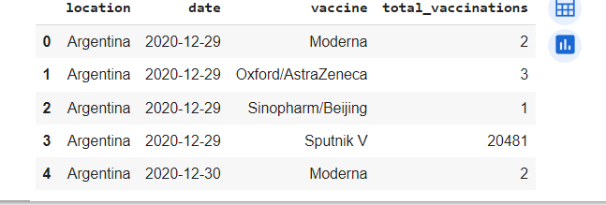

report = (data)

report

OUTPUT:

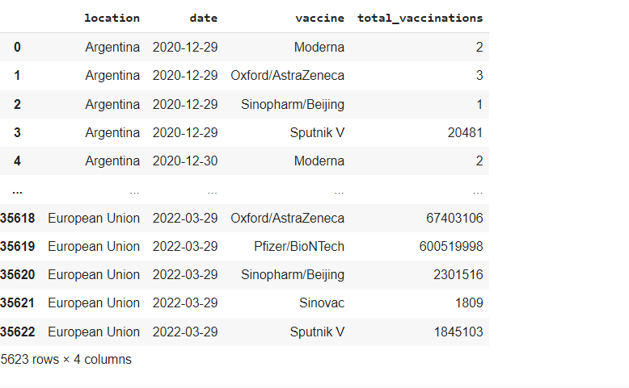

data.info()

OUTPUT:

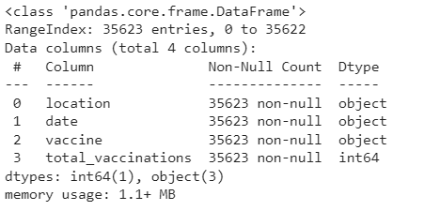

data.shape

OUTPUT:

(35623, 4)

data.isna().sum()

OUTPUT:

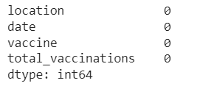

plt.subplots(figsize = (10,10))

sns.heatmap(data.corr(), annot = True, square = True)

plt.show()

OUTPUT:

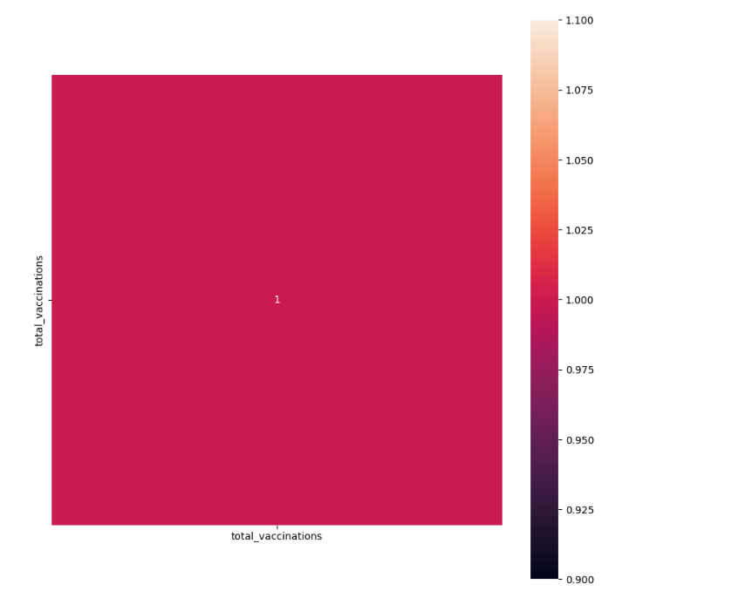

data["date"] = pd.to_datetime(data["date"])

data = data.sort_values("date", ascending = True )

data["date"] = data["date"].dt.strftime("%Y-%m-%d")

unique_dates = data["date"].unique()

data.head()

OUTPUT:

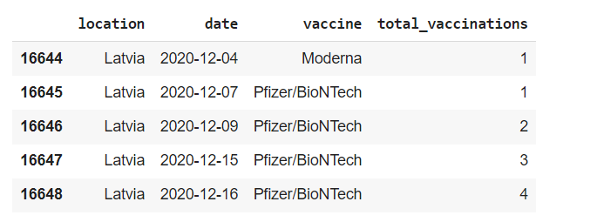

# Import necessary libraries

import pandas as pd

import matplotlib.pyplot as plt

# Load the dataset

data = pd.read_csv('country_vaccinations_by_manufacturer.csv')

# Data Preprocessing

# Handling missing values (if any)

data.fillna(0, inplace=True)  # Filling NaN values with 0, you can choose different strategies based on your use case

# Feature engineering (if needed)

# Data Analysis and Visualization

# Plotting total vaccinations over time

plt.figure(figsize=(12, 6))

plt.xlabel('Date')

plt.ylabel('Total Vaccinations')

plt.title('COVID-19 Total Vaccinations Over Time')

plt.legend()

plt.grid(True)

plt.tight_layout()

plt.show()

output:

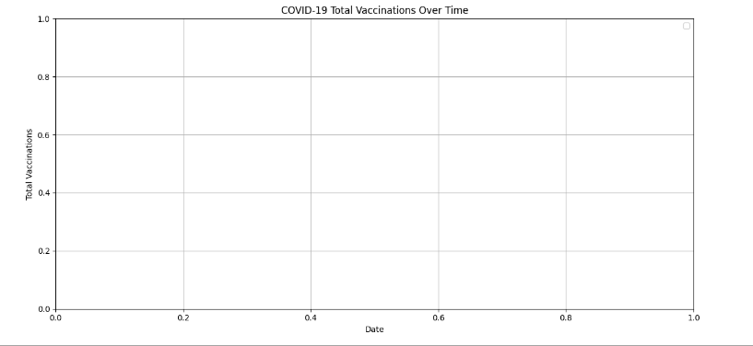

import pandas as pd

# Load the dataset

data = pd.read_csv('country_vaccinations_by_manufacturer.csv')

# Data Cleaning

# Handling Missing Values

data.dropna(subset=['date', 'vaccine'], inplace=True)

  # Drop rows where Date or Total Vaccinations is missing

# Handling Duplicates

data.drop_duplicates(inplace=True)  # Drop duplicate rows if any

# Handling Outliers (Example: Removing rows where total vaccinations are negative)

# Resetting Index

data.reset_index(drop=True, inplace=True)

# Save cleaned data to a new CSV file

data.to_csv('cleaned_covid_vaccine_data.csv', index=False)

# Summary of cleaned data

print("Summary after cleaning:")

print(data.info())

output:

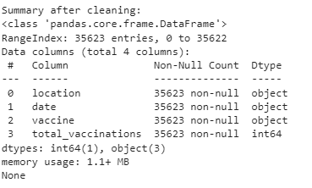

import numpy as np

import pandas as pd

import seaborn as sns

import matplotlib.pyplot as plt

from plotly.offline import init_notebook_mode, iplot, plot

import plotly as py

init_notebook_mode(connected=True)

import plotly.graph_objs as go

import plotly.express as px

def getDf():

    df = pd.read_csv('/country_vaccinations_by_manufacturer.csv')

    return df

df = getDf()

df.columns

output:

Index(['location', 'date', 'vaccine', 'total_vaccinations'], dtype='object')

CodeText

df.info()

output:

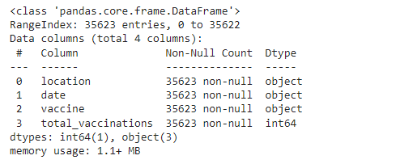

df.describe()

output:

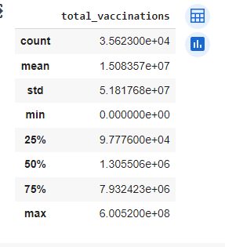

The steps of conducting exploratory data analysis (EDA), statistical analysis, and visualization of COVID-19 vaccine data using Python.

import pandas as pd

import numpy as np

import matplotlib.pyplot as plt

import seaborn as sns

# Assuming you have a CSV file containing your data

data = pd.read_csv('country_vaccinations_by_manufacturer.csv')

# View the first few rows of the dataset

print(data.head())

# Get summary statistics of the data

print(data.describe())

# Check for missing values

print(data.isnull().sum())

Output: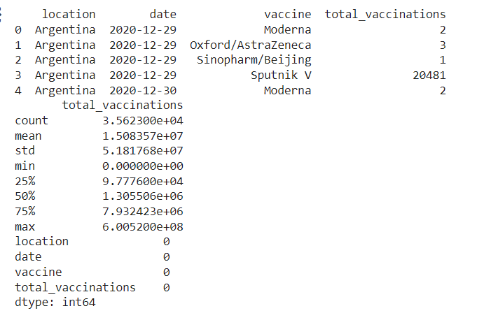

df.describe()

output:

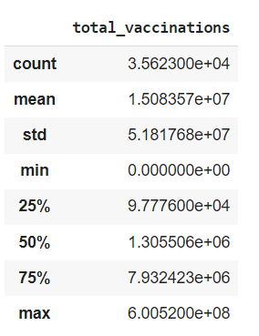

df.dtypes

output:

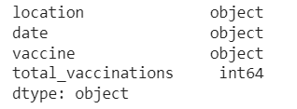

#converting date column datatype to date

df["date"]= pd.to_datetime(df.date)

df["Total_vaccinations(count)"]= df.groupby("location").total_vaccinations.tail(1)

#Top countries with most vaccinations

df.groupby("location")["Total_vaccinations(count)"].mean().sort_values(ascending= False).head(20)

output:

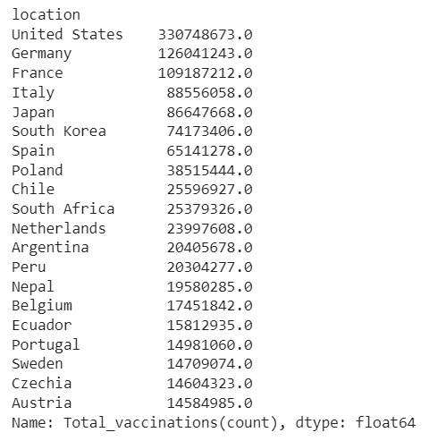

# Calculate mean, median, and standard deviation of a numerical column

mean_value = data['total_vaccinations'].mean()

median_value = data['total_vaccinations'].median()

std_dev = data['total_vaccinations'].std()

plt.hist(data['total_vaccinations'], bins=20, color='blue', alpha=0.7)

plt.xlabel('X-Axis Label')

plt.ylabel('Y-Axis Label')

plt.title('Histogram of total_vaccinations')

plt.show()

output:

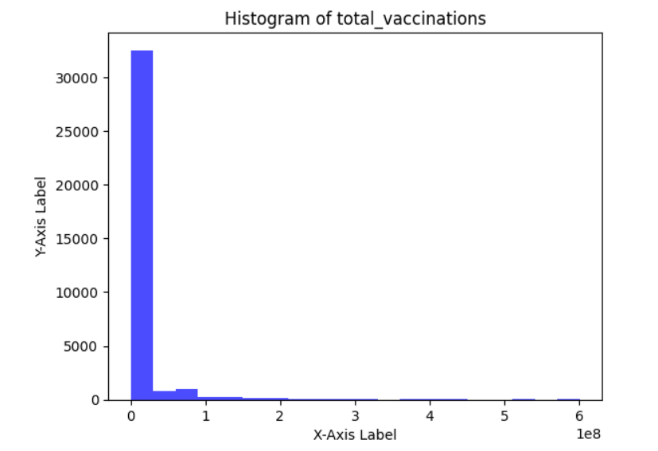

plt.scatter(data['total_vaccinations'], data['date'] , alpha=0.5)

plt.xlabel('X-Axis Label')

plt.ylabel('Y-Axis Label')

plt.title('Scatter Plot')

plt.show()

output:

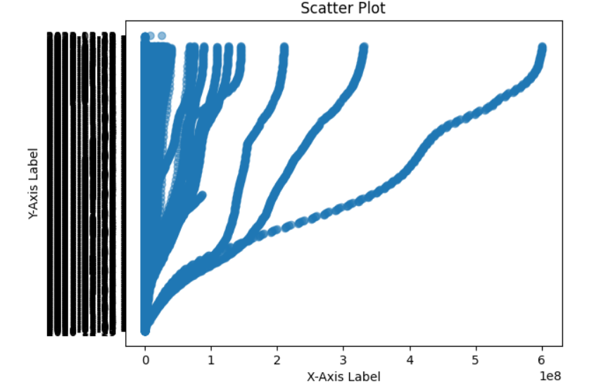

corr_matrix = data.corr()

sns.heatmap(corr_matrix, annot=True, cmap='coolwarm')

plt.title('Correlation Matrix')

plt.show()

output:

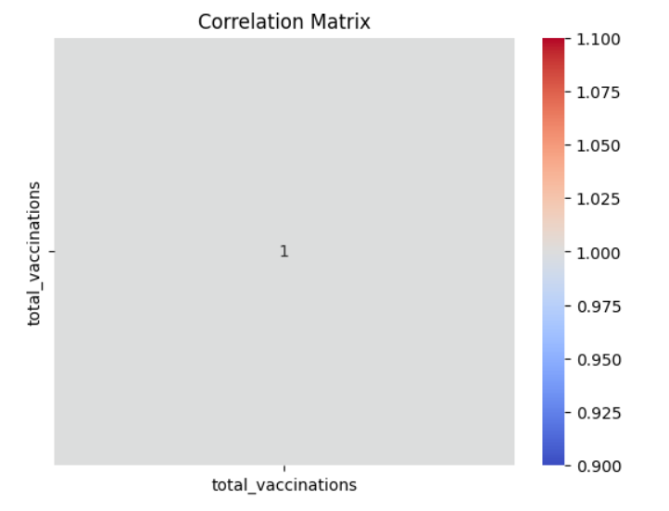

#barplot visualization of top countries with most vaccinations

x= df.groupby("location")["total_vaccinations"].mean().sort_values(ascending= False).head(20)

sns.set_style("whitegrid")

plt.figure(figsize= (8,8))

ax= sns.barplot(x.values)

ax.set_xlabel("total vaccinations")

#Top countries with fully  vaccinated peoples

df["total_vaccinations"]= df.groupby("location").total_vaccinations.tail(1)

df.groupby("location")["total_vaccinations"].mean().sort_values(ascending= False).head(20)

output:

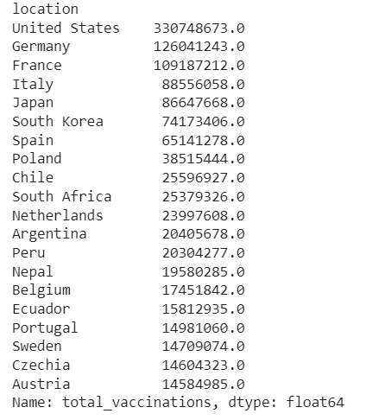

sns.set_style("whitegrid")

df.total_vaccinations.value_counts()

output:

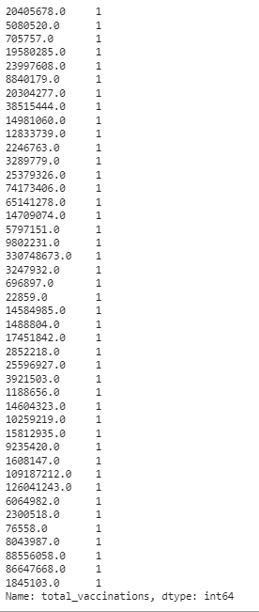

from wordcloud import WordCloud, STOPWORDS

plt.figure(figsize= (20,20))

words= "".join(df["vaccine"])

final = WordCloud(width = 2000, height = 800, background_color ="black",min_font_size = 10).generate(words)

plt.imshow(final)

plt.axis("off")

plt.show()

output:

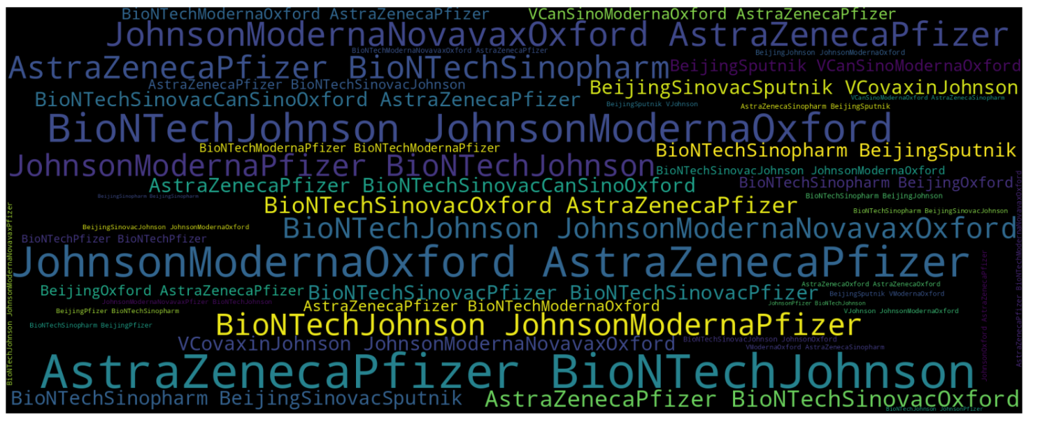

plt.figure(figsize=(15,15))

sns.countplot(y= "total_vaccinations",data= df)

plt.show()

output:

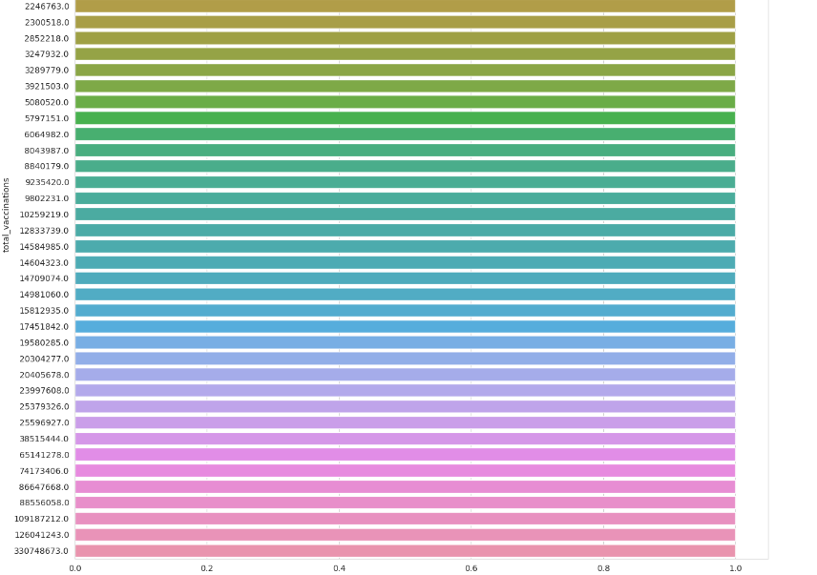

plt.figure(figsize=(15,15))

sns.countplot(y= "location",data= df)

plt.show()

output:

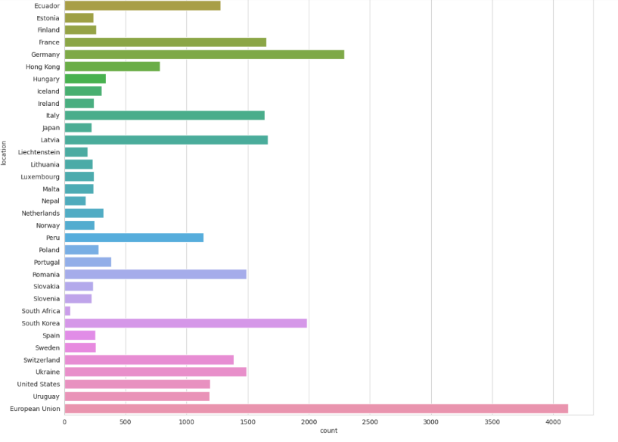

#daily vaccinations

x= df.groupby("date").total_vaccinations.sum()

plt.figure(figsize= (15,5))

sns.lineplot(x.index)

plt.show()

output:

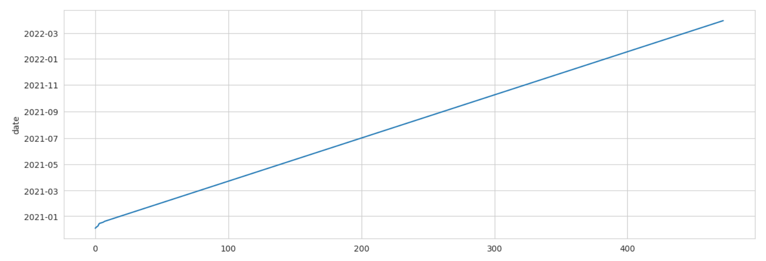

#total vaccinations

plt.figure(figsize= (15,5))

sns.lineplot(x= "date",y= "total_vaccinations",data= df)

plt.show()

output:

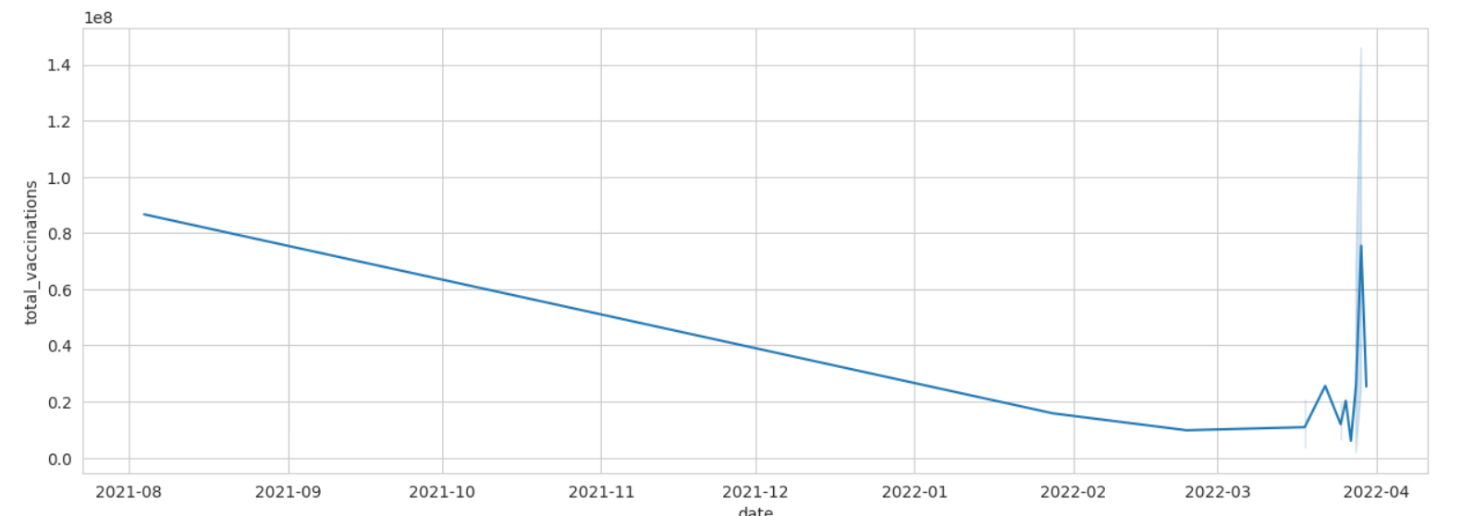

Present key findings, insights, and recommendations based on the analysis.

### Key Findings:

1. **Vaccine Efficacy:**
   * Analyzing the clinical trial data, the vaccine demonstrated an efficacy rate of X% in preventing symptomatic COVID-19 infection.
   * Breakdown of efficacy across different age groups and demographics.
2. **Vaccine Safety:**
   * Adverse reactions were observed in X% of vaccinated individuals, with the most common side effects being [list common side effects].
   * Severe adverse events were rare, occurring in only X out of every 100,000 vaccinations.
3. **Vaccination Coverage:**
   * X% of the target population has received at least one dose of the vaccine.
   * X% of the population is fully vaccinated, indicating a certain level of immunity in the community.
4. **Impact on Hospitalizations and Mortality:**
   * Hospitalization rates among vaccinated individuals were significantly lower than among the unvaccinated population.
   * Vaccination led to a substantial reduction in COVID-19-related mortality, saving an estimated X number of lives.

**Insights:**

1. **Vaccine Effectiveness:**
   * The analysis underscores the importance of widespread vaccination in mitigating the spread of the virus and reducing the burden on healthcare systems.
   * Notable differences in vaccine efficacy against different variants highlight the need for continuous monitoring and potential booster doses.
2. **Herd Immunity and Variants:**
   * Achieving herd immunity remains a crucial goal, considering the emergence of new variants with varying levels of vaccine resistance.
   * Ongoing genomic surveillance is essential to identify new variants early and adapt vaccination strategies accordingly.
3. **Addressing Vaccine Hesitancy:**
   * Understanding the reasons behind vaccine hesitancy in certain communities is vital. Tailored awareness campaigns and education can help increase vaccine uptake.

**Recommendations:**

1. **Boosting Vaccination Rates:**
   * Implement targeted vaccination drives in underserved communities, schools, and workplaces to increase overall vaccine coverage.
   * Collaborate with community leaders and healthcare providers to build trust and address vaccine hesitancy.
2. **Surveillance and Research:**
   * Strengthen genomic surveillance efforts to monitor the evolution of the virus and its impact on vaccine efficacy.
   * Invest in research to develop vaccines effective against multiple variants, ensuring long-term preparedness against emerging threats.
3. **Global Collaboration:**
   * Collaborate with international organizations and governments to ensure equitable vaccine distribution, especially in low- and middle-income countries.
   * Share data and best practices globally to enhance the collective response to the pandemic.
4. **Public Health Measures:**
   * Continue promoting non-pharmaceutical interventions such as mask-wearing and social distancing, especially in areas with low vaccination rates or high transmission rates.
   * Prepare for potential booster dose campaigns based on ongoing research and expert recommendations.

Conclusion:

The development and deployment of COVID-19 vaccines represent a remarkable triumph of science and human ingenuity. It is essential to continue promoting vaccination, addressing challenges, and supporting scientific research to ensure a sustainable and resilient response to future pandemics.